JAVA PROGRAMMING

LABORATORY

09-08-2020.

1. Write a java program that displays a common welcome message to greet all the students in an orientation program. Include a static method in your program that finds the occurrence of subjective pronouns in the message string. The program should display the identified subjective pronouns, the number of occurrences and the starting and ending index of it.

**Submitted By,**

Tamilvanan B.

2018503566.

09-08-2020.

MO Batch.

Program:

import java.util.Scanner;

public class greeting{

static int n;

static String[] stud = new String[100];

static int[] arr = new int[100];

public static int find(String str,String main){

String[] strgs = {"i","I","we","you","he","she","it","they"};

for(int i =0;i<strgs.length;i++){

if(strgs[i].equals(str)){

int startingPosition = main.indexOf(str);

int endingPosition = startingPosition + str.length() -1;

System.out.println("\n" + str + ": Start position=" + startingPosition + " End position=" + endingPosition + "\n");

return 1;

}

}

return 0;

}

public static void main(String... string){

int count = 0;

Scanner sc = new Scanner(System.in);

System.out.print("\nEnter the number of students:");

n = sc.nextInt();

for(int i=0;i<n;i++){

System.out.print("Enter the Name: ");

stud[i] = sc.next();

System.out.print("Enter the Roll number: ");

arr[i] = sc.nextInt();

}

System.out.println("\n");

for(int i=0;i<n;i++){

System.out.println("\n");

System.out.println("Name: " + stud[i]);

System.out.println("Roll Number: " + arr[i]);

}

String str = "I welcome you all to Java Lab Session";

System.out.println("The greeting message is " + "\"" + str + "\"\n");

String[] strs = str.split(" ");

for(int i=0;i<strs.length;i++){

if(find(strs[i],str) != 0){

count++;

}

}

System.out.println("\nThe number of subjective pronouns present is/are "+count);

}

}

Output:

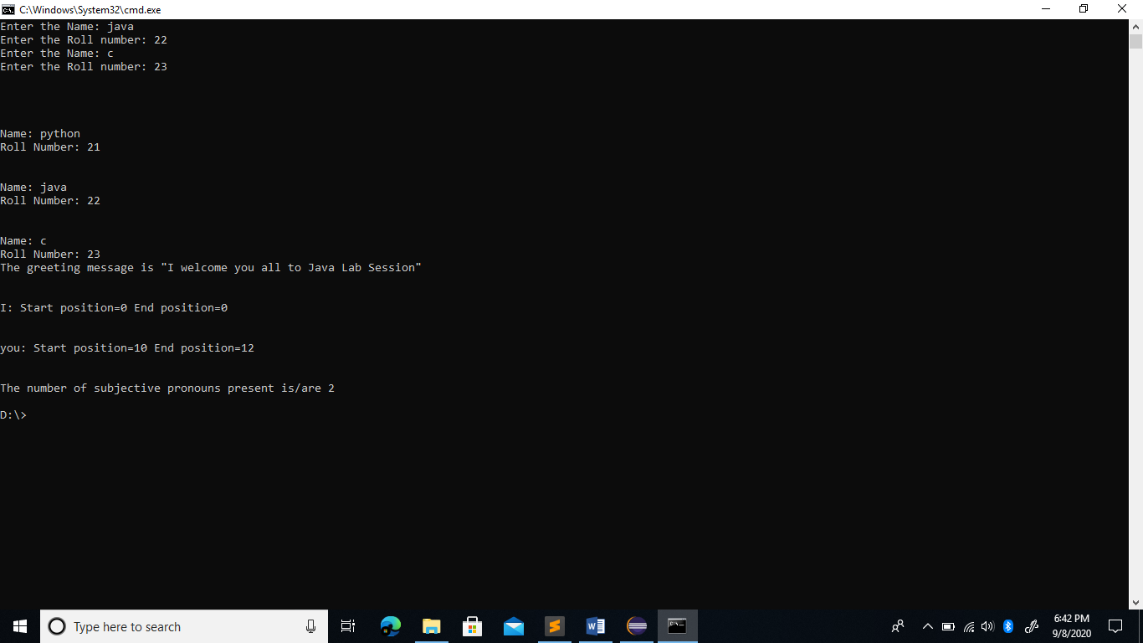

2. Create a class called Healthcare that keeps track of the patients name, the patient id, roomcount, and room number for a hospital. Use appropriate data types for these fields. Write two constructors for the class to initialize the instance variables with values (specific to the domain). For the formal parameters, use the same variable names as your instance variables.

* Use **“this”** keyword to distinguish between the instance variables and the parameter variables.
* Invoke current class method using ‘this’ keyword.
* Include a roomCheck () static method for the class. Include a patientcheck() method that accepts a this keyword as parameter.
* Include two methods vacate (patient ID) and admit (Patient ID) for the class. “vacate” and “admit” methods should adjust the room count when a patient vacates the room and when a new patient is admitted appropriately. Use **“this”** keyword to return the instance variables.

The program should keep track of the total roomcount and display the status of rooms available along with the patient-details.

Program:

import java.util.*;

class patient_room{

String name;

int id,room_no;

static int roomcount=0;

static int available=0;

static HashMap<Integer,Integer> map=new HashMap<Integer,Integer>();

patient_room(){

this.name="";

this.id=-1;

this.room_no=this.roomcount+1;

this.roomcount++;

}

patient_room(String name,int id){

this();

this.name=name;

this.id=id;

patient_room.map.put(id,this.roomcount);

}

static int roomCheck()

{

return patient_room.available;

}

boolean is_available()

{

if(this==null) return true;

return false;

}

static int patientcheck(int id)

{

if(patient_room.map.get(id)==null) return -1;

return patient_room.map.get(id);

}

void vacate()

{

patient_room.map.remove(this.id);

this.id=-1;

this.name="";

patient_room.available++;

}

patient_room admit(String name,int id,int room_no)

{

this.name=name;

this.id=id;

patient_room.map.put(id,room_no);

patient_room.available--;

return this;

}

}

public class healthcare{

static void print()

{

System.out.println("Enter the choice: \n");

System.out.println(" 1) Create Room\n 2) Admit\n 3) Vacate\n 4) Patient Check\n 5) Room Check\n 6) Exit\n");

System.out.print("Enter the option: ");

}

public static void main(String args[])

{

Scanner sc= new Scanner(System.in);

int n=0,i,j;

String name;

int id,num,ans;

patient_room[] p=new patient_room[100];

while(n!=6)

{

healthcare.print();

n=sc.nextInt();

switch(n){

case 1:

System.out.println("Enter the patient name: ");

name=sc.next();

System.out.println("Enter the patient id: ");

id=sc.nextInt();

p[patient_room.roomcount]= new patient_room(name,id);

break;

case 2:

System.out.println("Enter the patient name: ");

name=sc.next();

System.out.println("Enter the patient id: ");

id=sc.nextInt();

System.out.println("Enter the room number to be admitted: ");

num=sc.nextInt();

if(num<patient_room.roomcount && p[num-1].is_available())

p[num-1]=p[num-1].admit(name,id,num);

else

System.out.println("The requested room is not available! ");

break;

case 3:

System.out.println("Enter the room number to be vacated: ");

num=sc.nextInt();

if(num<patient_room.roomcount && p[num-1].is_available())

System.out.println("The room is already empty! ");

else

p[num-1].vacate();

break;

case 4:

System.out.println("Enter the patient id to be checked: ");

num=sc.nextInt();

ans=patient_room.patientcheck(num);

if(ans==-1)

System.out.println("The patient has been discharged! ");

else

System.out.println("The patient is in room number: " + ans);

break;

case 5:

num=patient_room.roomCheck();

System.out.println("There are " + num + " number of rooms available! ");

break;

case 6:

break;

}

}

}

}

Output:

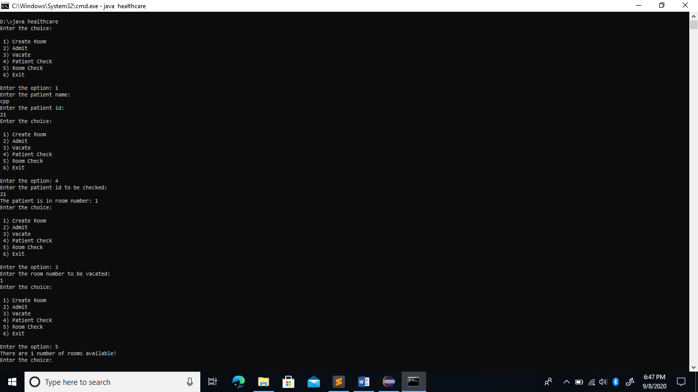

3. In your chemistry laboratory, you have taken eight observations for an experiment. The mean and variance for your observations are 11 and 11.25. Assume, your laboratory notebook is missing and you remember only six observations out of eight which you have noted. The six observations you remember are 7, 8, 11, 13, 13 and 14.Write a java program that considers this scenario and finds the remaining two missed observations.

Program:

import java.util.Scanner; public class Challenge {

public static void main(String[] args) { double mean, variance;

Scanner sc = new Scanner(System.in);

System.out.print("Enter number of observations:");

int n = sc.nextInt();

System.out.print("Enter the Mean: ");

mean = sc.nextDouble();

System.out.print("Enter the Variance: ");

variance = sc.nextDouble();

double[] observations = new double[n - 2];

System.out.println("Enter the observations:");

for(int i = 0; i < n - 2; i++)

observations[i] = sc.nextDouble();

double x, y, z; x = n * mean;

for(int i = 0; i < n - 2; i++)

x -= observations[i];

y = n * variance;

for(int i = 0; i < n - 2; i++)

y -= (double)Math.pow(observations[i] - mean, 2);

z = y - (2 * mean * mean) + (2 * mean * x);

double a, b, c;

a = 2;

b = -2 * x;

c = (x * x) - z;

double d = (b * b) - (4 * a * c); double r1;

if(d >= 0) {

r1 = (-b - Math.sqrt(d)) / (2 * a); if(r1 >= 0) {

double r2 = x - r1;

System.out.println("The two missing observations are " + String.format("%.5f", r1) + " and " +String.format("%.5f", r2));

}

else {

System.out.println("The missing observations cannot be found");

}

}

sc.close();

}

}

Output:

